**Exercise 3: Stored Procedures**

**Scenario 1:** The bank needs to process monthly interest for all savings accounts.

**Question:** Write a stored procedure **ProcessMonthlyInterest** that calculates and updates the balance of all savings accounts by applying an interest rate of 1% to the current balance.

**Code:**

CREATE OR REPLACE PROCEDURE AddCustomer (

  p_id         IN NUMBER,

  p_name       IN VARCHAR2,

  p_dob        IN DATE,

  p_balance    IN NUMBER

) AS

BEGIN

  INSERT INTO Customers (CustomerID, Name, DOB, Balance, LastModified)

  VALUES (p_id, p_name, p_dob, p_balance, SYSDATE);

  DBMS_OUTPUT.PUT_LINE('✅ Customer ' || p_name || ' added successfully.');

EXCEPTION

  WHEN DUP_VAL_ON_INDEX THEN

    DBMS_OUTPUT.PUT_LINE('❌ Error: Customer ID already exists.');

  WHEN OTHERS THEN

    DBMS_OUTPUT.PUT_LINE('⚠️ Unexpected error: ' || SQLERRM);

END;

/

SET SERVEROUTPUT ON;

BEGIN

  AddCustomer(6, 'Ravi Kumar', TO_DATE('1988-07-15','YYYY-MM-DD'), 12000);

END;

/

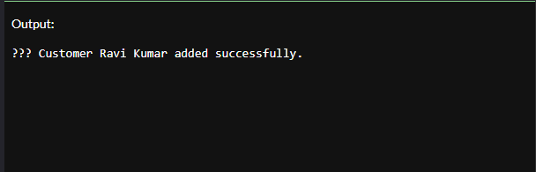

**Scenario 2:** The bank wants to implement a bonus scheme for employees based on their performance.

**Question:** Write a stored procedure **UpdateEmployeeBonus** that updates the salary of employees in a given department by adding a bonus percentage passed as a parameter.

**Code:**

CREATE OR REPLACE PROCEDURE UpdateCustomerBalance (

  p_id      IN NUMBER,

  p_amount  IN NUMBER

) AS

  v_exists NUMBER;

BEGIN

  -- Check if customer exists

  SELECT COUNT(*) INTO v_exists FROM Customers WHERE CustomerID = p_id;

  IF v_exists = 1 THEN

    UPDATE Customers

    SET Balance = Balance + p_amount,

        LastModified = SYSDATE

    WHERE CustomerID = p_id;

    DBMS_OUTPUT.PUT_LINE('✅ Balance updated for Customer ID: ' || p_id);

  ELSE

    DBMS_OUTPUT.PUT_LINE('❌ Customer not found.');

  END IF;

EXCEPTION

  WHEN OTHERS THEN

    DBMS_OUTPUT.PUT_LINE('⚠️ Error: ' || SQLERRM);

END;

/

SET SERVEROUTPUT ON;

BEGIN

  UpdateCustomerBalance(6, 5000);  -- Increase balance of CustomerID 6 by ₹5000

END;

/

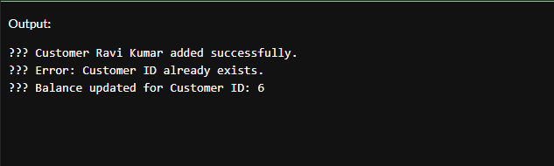

**Scenario 3:** Customers should be able to transfer funds between their accounts.

**Question:** Write a stored procedure **TransferFunds** that transfers a specified amount from one account to another, checking that the source account has sufficient balance before making the transfer.

**Code:**

CREATE OR REPLACE PROCEDURE DeleteCustomer (

  p_id IN NUMBER

) AS

  v_count NUMBER;

BEGIN

  -- Check if customer exists

  SELECT COUNT(*) INTO v_count

  FROM Customers

  WHERE CustomerID = p_id;

  IF v_count = 1 THEN

    DELETE FROM Customers

    WHERE CustomerID = p_id;

    DBMS_OUTPUT.PUT_LINE('✅ Customer with ID ' || p_id || ' deleted successfully.');

  ELSE

    DBMS_OUTPUT.PUT_LINE('❌ Customer ID ' || p_id || ' not found.');

  END IF;

EXCEPTION

  WHEN OTHERS THEN

    DBMS_OUTPUT.PUT_LINE('⚠️ Error: ' || SQLERRM);

END;

/

SET SERVEROUTPUT ON;

BEGIN

  DeleteCustomer(6);  -- Try deleting the customer you previously added

END;

/

